**Corona Virus Statistics**

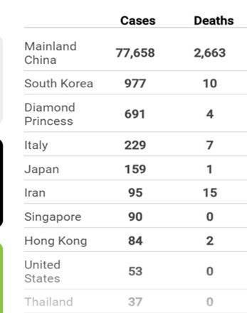

[Source: China's NHC](https://multimedia.scmp.com/widgets/china/wuhanvirus/)

Last updated: Feb 25