BRi WAREHOUSE CLOSURE DATES OVER CHRISTMAS 2023 & NEW YEAR 2024

To our Valued Customers,

We would like to advise you of our closing dates over the coming Christmas / New Year period.
Please find National Operating Schedule below:

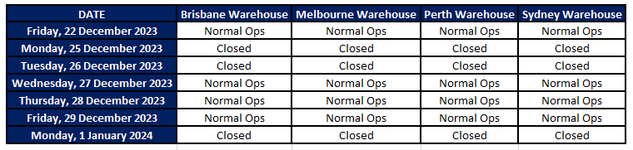

Order Cut-offs Pre XMAS-Eve - Thursday 21st of December, 2023:

- Friday 22nd of December will be our last despatch day prior to XMAS Eve.
- Next orders despatched will be Wednesday 27th of December 2023

Order Cut-offs Pre-New Year’s Eve (Thursday the 28th of December):

- Order cut-off on the Thursday 28th of December, will be 10am.
- Next orders despatched will be Tuesday 2nd of January 2024

Feel free to contact your BRi Account Manager should you have any further questions or concerns in relation to this schedule.

On behalf of everyone here at BR International, we wish you a safe and enjoyable Festive Season. We are grateful for your support and sincerely hope that we all enjoy a prosperous 2024.

Yours Sincerely,
BRI Team

