**RE- 215-2020 - New import permit requirements for apiaceous vegetable seed species commencing from 30 March 2021**

**Figure 1.** Implementation timeframes for import permit introductions for apiaceous seed species including *Anthriscus cerefolium* (chervil), *Apium graveolens* (celery), *Foeniculum vulgare* (fennel), *Pastinaca sativa* (parsnip) and *Petroselinum crispum* (parsley), for consumption and sowing.

[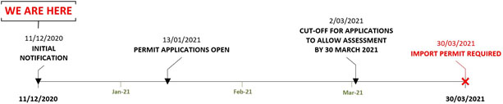](https://www.agriculture.gov.au/sites/default/files/images/filename.type)

Please note:

* Consignments that arrive in Australian territory prior to 30 March 2021 will be permitted entry without an import permit.
* The department will not facilitate the clearance of goods that require an import permit but arrive without one. Consignments that arrive on or after 30 March 2021 without an import permit, including scenarios where an application is currently under consideration, will be directed for export or required to be destroyed in an approved manner.