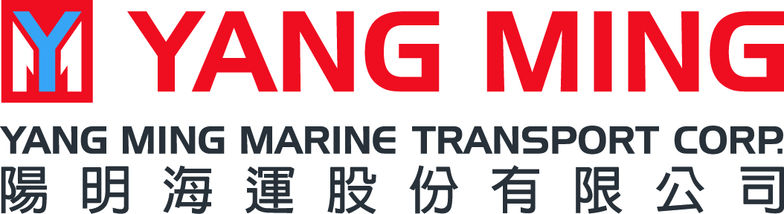

TRADE NOTICE
RATE RESTORATION
Far-East Asia to Australia
Dear esteemed customers,

Good day,

Owing to reflect operation cost and to provide stable and high quality service, YML will adjust ocean freight with origin in Korea, China (Including Hong Kong) and Taiwan to ports in Australia.
The quantum as below:

Effective from 2016/ 1st/ July (on board day)
R/R - (RATE RESTORATION)
USD300/20'DC, USD600/40'DC&HQ

Kindly refer to above information, thanks for your understanding and support.
For any further information, please kindly contact our local sales representative.

Yours sincerely,

YANG MINGMARINE TRANSPORT CORP.
Dated 31/MAY/2016

